Social Media platform

***Objective***

1. *Design ER diagram for Social Media Platform*
2. *Transform the logical model created in point 1 into a physical model using RDBMS (MySQL). Create the database, tables (at least ten records each) and write SQL queries for tasks such as inserting, deleting and updating records and complex queries for retrieving useful information.*
3. *Implement the same database system with a NoSQL database such as MongoDB. Write equivalent NoSQL queries for the NoSQL database.*

# Task 1

Following entities and their relationships have been considered for ER diagram of social media platform.

Users / Locations / Albums / Photos / Videos / Posts / Comments

Social Media platform Where **Users** can follow their friends, Add their **Photos, Videos, Posts** and they can have **Albums** with their photos and Videos. Creating Album is a prerequisite for adding photos and videos. These posts can be tagged with the **Locations** for those.Followers can add **Comments** on those posts

*ER model which clearly shows relationships between entity types in the database.*

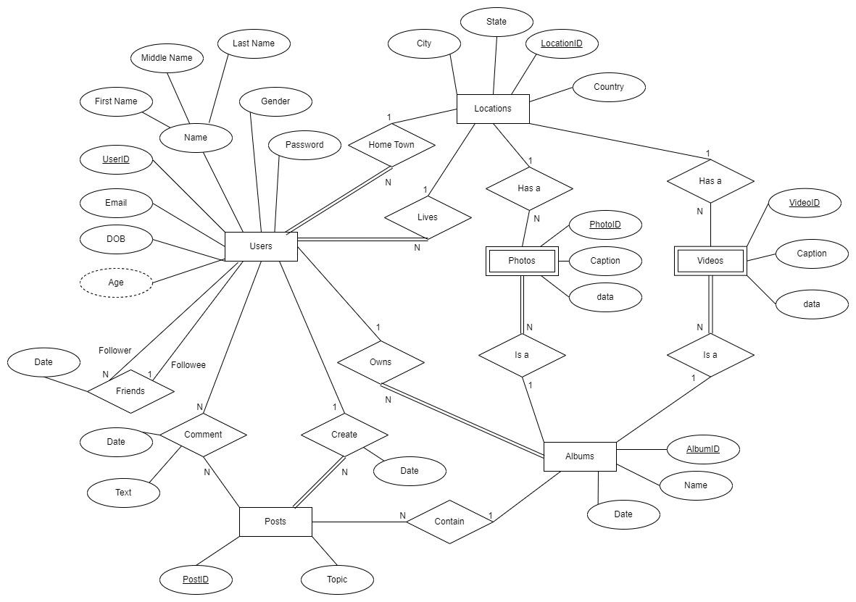

*Logical model which includes primary keys and foreign keys for each relation in the database.*

*Brief explanation of your ER model and Logical model*

* Each User has a unique UserID, name is a composite attribute which has first name, middle name and last name, gender, email, DOB, and password are other attributes. The age is a derive attribute from DOB.
* Users got unary One-to-Many Friends relationship.
* Each Location has a unique LocationID, city, state and country. User has exactly one location for hometown and living place. Many Users can be from same location for hometown and current location. There can be Location’s which are not have any User association.
* User can create/own none or multiple albums, each of which has an albumID, name and date.
* Each album has zero or more Photos and zero or more Videos.
* Each Photo has a unique PhotoID, caption, data and maybe link to Location for geotagging.
* Each Video also has unique VideoID, caption, data and maybe link to Location.
* Each Photo and Video need Album to hold.
* Each User may create Post, Creation relationship has a create date, Post has a unique PostID, topic and it may contain one album. Each album can be part of multiple Posts.
* Each Post maybe commented by multiple Users and each User may do multiple comments on post. Each Comment has date and text.All entities are represented by tables in logical model. Entities will hold primary key.
* If relationship is One-to-Many, Many side will hold primary key of the other entity as foreign key within that entity.
* Many-to-Many relationship will result in creating new entity holding both primary keys as it’s unique key (composite key)
* Relationship attributes will be move to entity in Many side.

# Task 2

Steps to execute scripts:

1. Navigate to directory where mysql.exe is located.

cd C:\program Files\MySQL\MySQL Server 8.0\bin

1. Execute following command

mysql -u [username] -p[password] [database_name] < [script_name].sql > [output_name].txt

Note: Scripts and output of the script is upload for your reference.

# Task 3

JavaScript file created for MongoDB script so that it can be executed easily. Output always returns to txt file.

**Execution steps:**

Place the .js file into folder in your PC and execute mongosh command as below.

mongosh localhost:27017 mongo_social_media_platform.js >> mongo_social_media_platform.txt

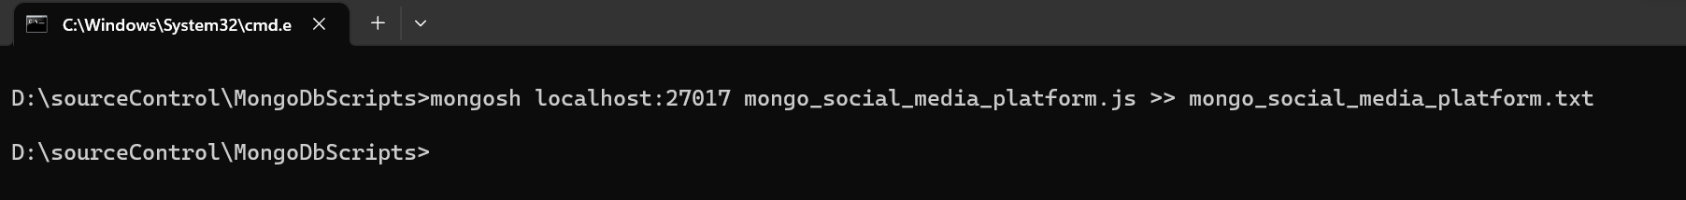

* I am executing the command from the same folder where I have placed .js file. This is possible because my mongosh is configured in environment variables and can be executed from anywhere.
* If setup is different. Execute from mongosh folder giving full path to .js and .txt file.

